Percentages
330
- Your number is:

- 10% x 330 ___________________
- Find 50% x 330 ____________________
- Find 20% x 330 ____________________
- Find 1% x 330 _____________________
678

- Your number is:
- Find: 35% of 678 ___________________
- Find 2% of 678 ____________________
- Find 88% of 678 ___________________
Find 45% of 678 _____________________
120

- The answer is

- 50% of ________ is 120
- 75% of ________ is 120 (when rounded to nearest whole number)
- 14% of ________ is 120
- 5% of _________ is 120

- a. A car is worth £17,000. In one year, it loses 7% of its value. What is the new cost of the car?
b. The next year it loses 26% of its new value. How much is the car worth at the end of the second year? ____________________

- The price of these cottages has decreased by 10% in the last year. Complete the table:
Cottage | Original Cost | 10% decrease | New Cost
Pear Tree Cottage | £253, 660
Rose Valley Cottage | £217,450
Mill Farm Cottage |  | £34, 652.90

- A horse riding club has 650 members.
62% of the members are female.
14% of the male members are children.

- How many female members are there? ____________
- How many male adult members are there? ____________

- There are 425 cakes at the bakers.
Ipsley buy 28% of the cakes to give out as attendance rewards for those who have been at school every day.
How many children will be getting a cake? __________

- This pie chart shows some different coloured roses in a florist.
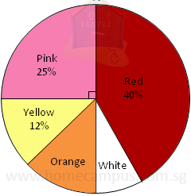

- What percentages of the flowers are orange? ______________

- There are 36 yellow roses, how many roses are there altogether? _____________

