Q1. Match the improper fraction to its correct mixed number equivalent.
14/8 |  | 1 ½
14/3 |  | 4 ¼
18/12 |  | 3
15/5 |  | 1 ¾
17/4 |  | 4 2/3

Q.2 Decide if these equivalent fractions are correct or incorrect. If they are incorrect, write the correct answer next to them.

Original Fraction | Equivalent fraction | Correct or Incorrect? | Correct answer
4/8 | ½
2/6 | ¼
5/10 | 3/6
¾ | 6/8
8/12 | 1/3
12/16 | ¼
5/10 | 2/20
1/10 | 2/20
14/28 | 7/14
2/7 | 3/14

Q.3 Show me the following: (use the signs > and < to help you)
- A decimal number that is greater than 1.5, but less than 1.6
- A decimal number that is less than 1, but more than 0.9
- A decimal number less than 0.01, but more than 0
- Two numbers, both with two decimal places, where the first is greater than the second. They both have to have the same digit in the ones column

Q.4 These fractions, decimals and percentages are in the incorrect place. Put them into the correct order, from smallest to biggest.
73% 0.081 8/10 43/100 0.043 45%

Q.5 Ratio:
Assume 1 part is always 8.
What is the total amount for all these different ratios?
Ratio | Total Amount
1:2
2:3
1:4
2:4
1:5
3:7
1:9
5:7
Q.6 Sabrina has 12 green brooms and 8 red brooms

(a) What fraction of her brooms are green? Simplify your answer.
(b) What percentage of her brooms are red?

Q.7 Clarissa’s school has 800 pupils.
4/10 of the pupils walk to school
15% of the pupils cycle to school
How many pupils neither walk or cycle?

Q.8 Decide if these equivalent decimals and fractions are correct or incorrect. If they are incorrect, write the correct answer next to them.
Original Decimal | Equivalent fraction | Correct or Incorrect? | Correct answer
4.5 | 4½
0.25 | ¼
1.8 | 1 8/100
0.2 | 1/5
3.6 | 3 3/10
0.3 | 3/10
3.65 | 3 6/5
2.1 | 2 1/5
2.2 | 2 1/5
2.44 | 2 11/25

Q.9 Joan and Hart are playing badminton.
For every 2 games Joan wins, Hart wins 5.
How many games would Joan win if they played 84 times?

Q.10. Melissa is making a meat based pizza.
Here is a list of her ingredients:
(Makes 4 pizzas)
500g flour
280g cheese
400g tomato sauce
200g pepperoni
160g ham
240g sausage
- How many grams of cheese would she need for 1 pizza?
- If she used 250g of flour, how much ham would she need?
- If she needed 360g of sausage, how much pepperoni would be needed?
- She needs to make enough for 10 pizzas. How many grams of cheese will she need?

Challenge:
See picture.
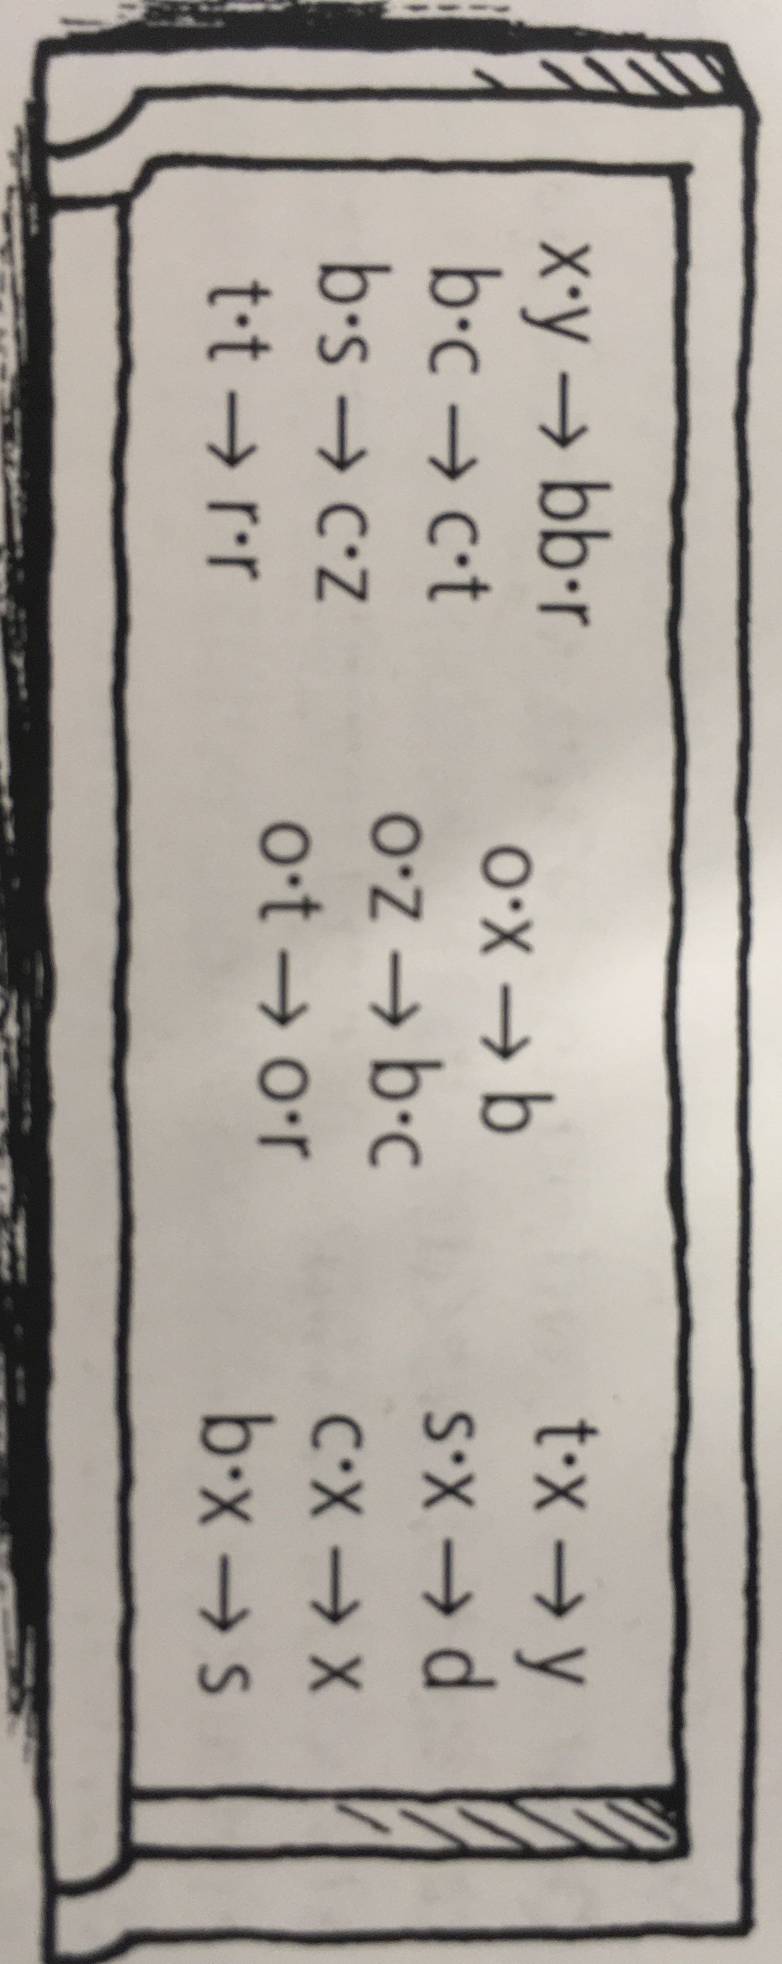
Each digit 0-9, is represented by one letter only. The arrows show what the number becomes once doubled.
0 is ‘o’. Find the solution for all the others.

