Multiplying and Dividing Fractions

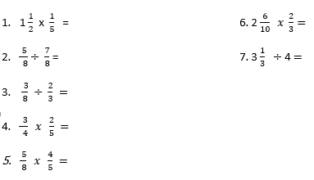

- I have a cake, which I would like to eat over two days. On day 1 and day 2 I will use exactly the same amount of cake. On day 1 I am feeding 8 people and on day 2, 6 people.
- How much cake will my guests receive on day 1?
- Then on day 2?

- Write the two missing values to make these equivalent fractions correct
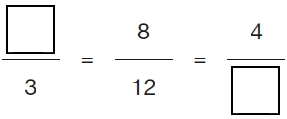.

- Each of these diagrams is divided into equal parts.
Some of the parts are shaded.

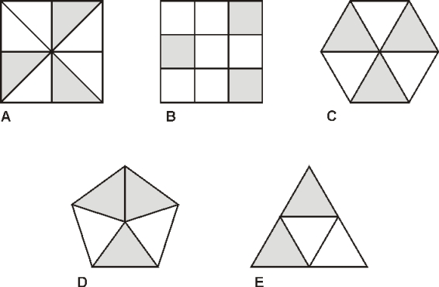

Write the letters of all the diagrams that have exactly shaded. ___________________________

- I have 10 friends round for tea. Each person eats $1/3$ of a pizza. How many pizzas would I need to buy so they all get 1/3 each?

- The length of a day on Earth is 24 hours.
The length of a day on Mercury is 58 times the length of a day on Earth.
What is the length of a day on Mercury, in hours?

